|  |
| --- |
| **Ex,no 2. DDL Commands with Constraints – PRIMARY, FOREIGN KEY, UNIQUE,CHECK** |
|  |
|  |

1)Alter the table STUDENT with following structure.

|  |  |  |
| --- | --- | --- |
| S.No | Column | Constraints |
| 1 | RegNo | PRIMARY KEY |
| 2 | MobileNo | NotNull |

Ans)

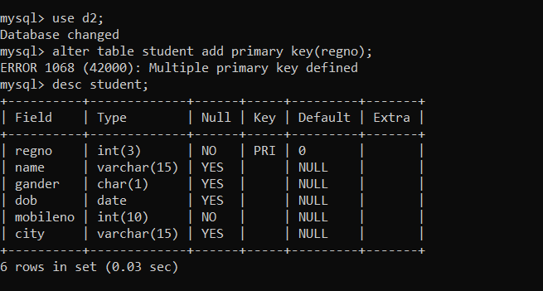

1. Alter the table name FACULTY with following structure. The DeptNo in this table refers the DeptNo in the DEPARTMENT table.

|  |  |  |
| --- | --- | --- |
| S.No | Column | Constraints |
| 1 | FacNo | PRIMARY KEY |
| 2 | Gender | Check ‘M’ or ‘F’ |

Ans)

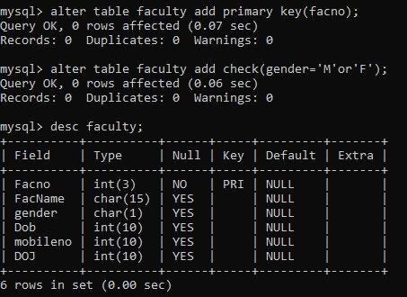

3)Alter the FACULTY table is successfully created, test if you add a constraint FOREIGN KEY to the DeptNo of this table.

Ans



4)Alter the table name DEPARTMENT with following structure.

|  |  |  |
| --- | --- | --- |
| S.No | Column | Constraints |
| 1 | DeptNo | PRIMARY KEY |

Ans)

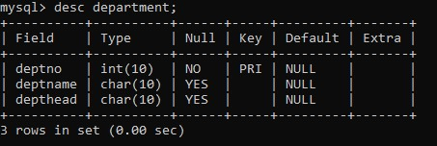

5. Alter the table name COURSE with following Structure

|  |  |  |
| --- | --- | --- |
| S.No | Column | Constraints |
| 1 | CourseNo | PRIMARY KEY |
| 2 | SemNo | 1 to 6 |

Ans)

